Lab Experiment: Basic Video Processing Operations
Experiment No: 6
Aim
To read a captured video using Python and display the video in normal, slow motion, and fast motion using the OpenCV library.
Tools Required
- Python 3.x
- OpenCV (cv2)
- VS Code / PyCharm / Jupyter Notebook
- Captured Video File (e.g., video.mp4)
Procedure
- Install the OpenCV library using:
pip install opencv-python
- Import the OpenCV library.
- Read the captured video using cv2.VideoCapture().
- Read each frame of the video in a loop.
- Display the video in normal speed.
- Press S to play the video in slow motion.
- Press F to play the video in fast motion.
- Press Q to stop the video and close the window.
Code
import cv2
cap = cv2.VideoCapture("samplev.mp4")
if not cap.isOpened():
print("Error opening video file")
exit()
while True:
ret, frame = cap.read()
if not ret:
break
# Resize to smaller size
small_frame = cv2.resize(frame, (400, 300)) # width, height
cv2.imshow("Small Video Screen", small_frame)
if cv2.waitKey(30) & 0xFF == ord('q'):
break
cap.release()
cv2.destroyAllWindows()
Output
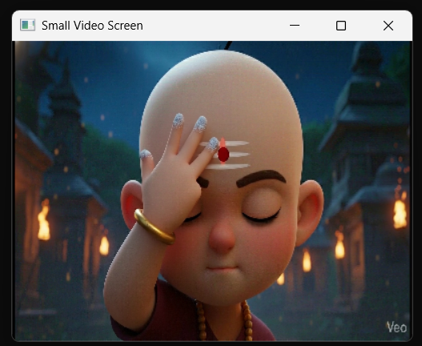.

Result
The captured video was successfully read using Python and displayed using the OpenCV library. The video playback speed was controlled successfully in normal, slow motion, and fast motion modes.

